STEP 1)

Created an EC2 Instance. t2 micro eligible and working on Ubuntu AMI. Configured the security groups.

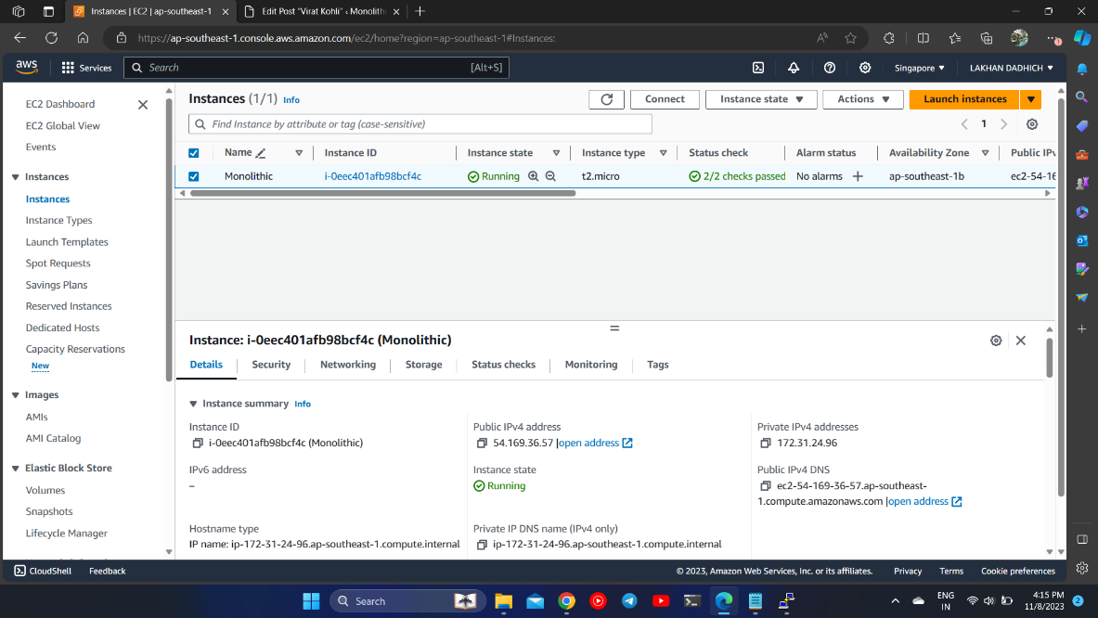STEP 2)

Installed Dependencies. Php and apache2. (Lamp Stack Package)

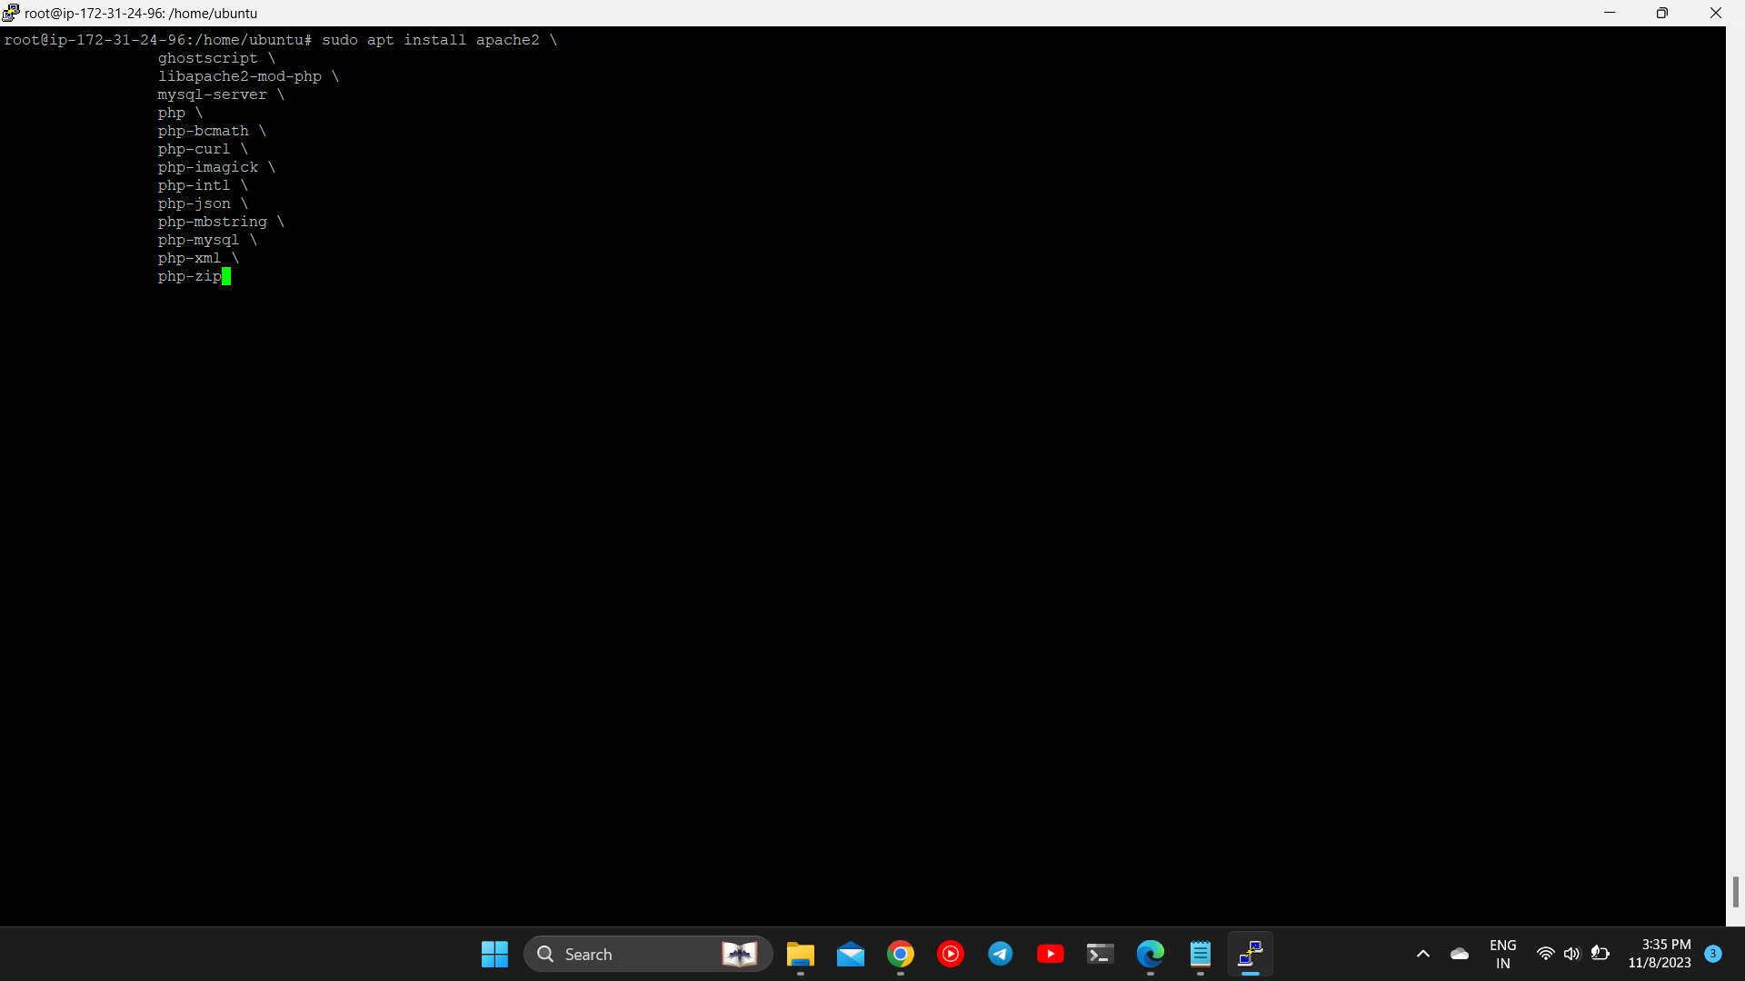

STEP 3)

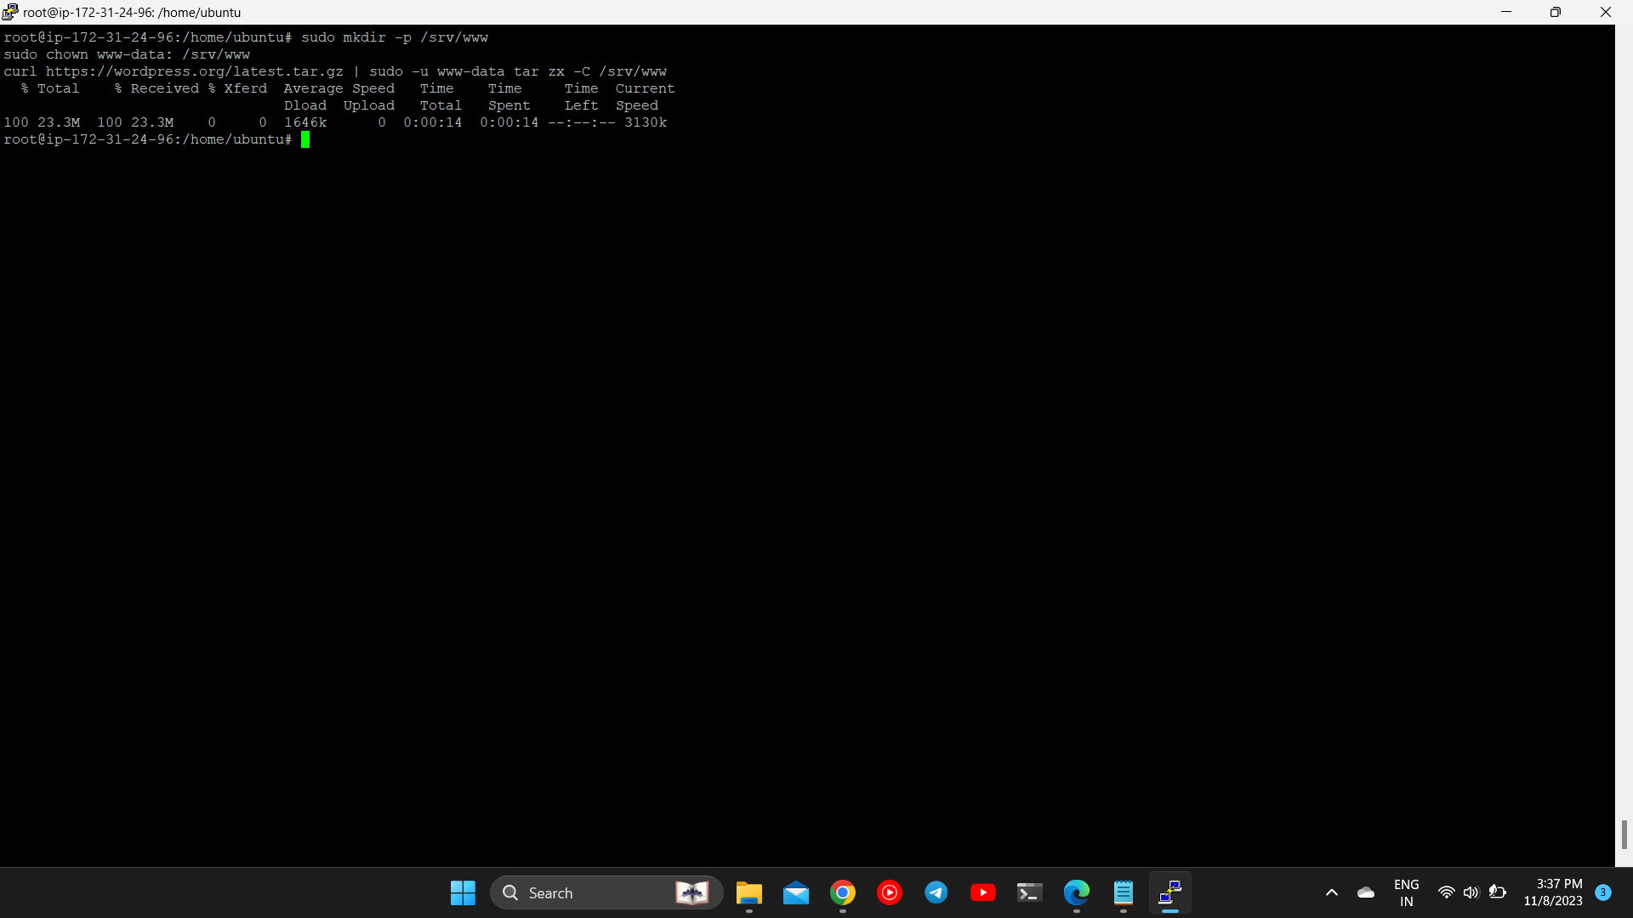Installed Wordpress. Created the installation directory and downloaded the file from [WordPress.org](http://wordpress.org/):

STEP 4) Configured Apache for Wordpress. Created Apache site for WordPress. Created /etc/apache2/sites-available/wordpress. conf file.

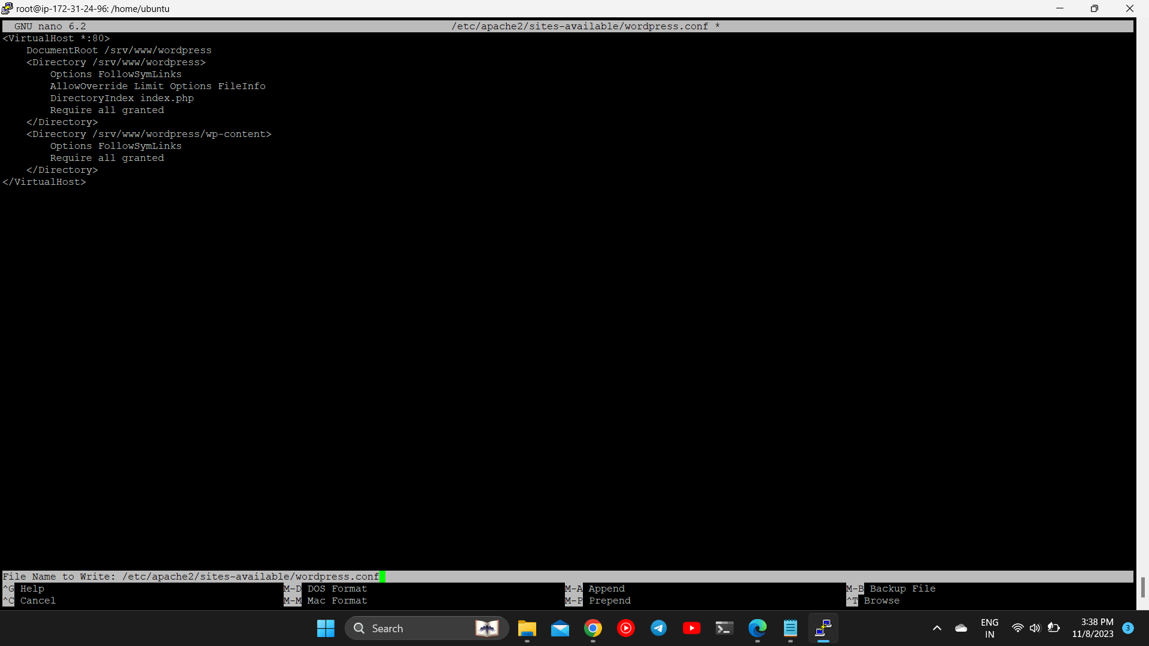

STEP 5)

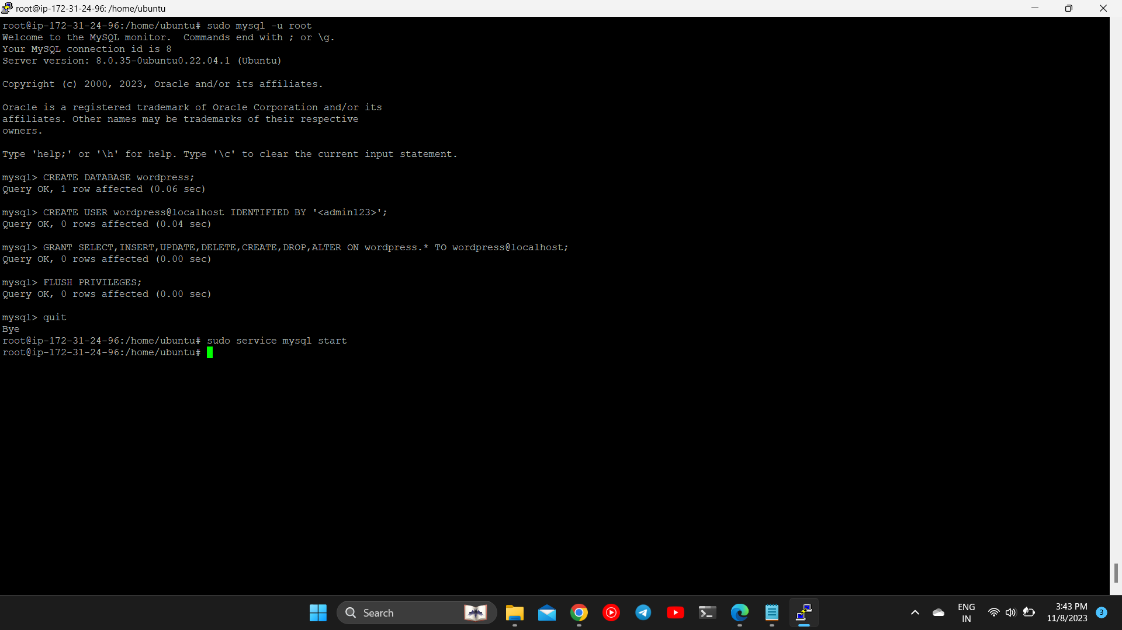Installed MySQL and Configured MySQL Database.

STEP 6) Configured Wordpress and Connected it to the Database. Configured the wp-config.php file and added the secret AUTH key to it. 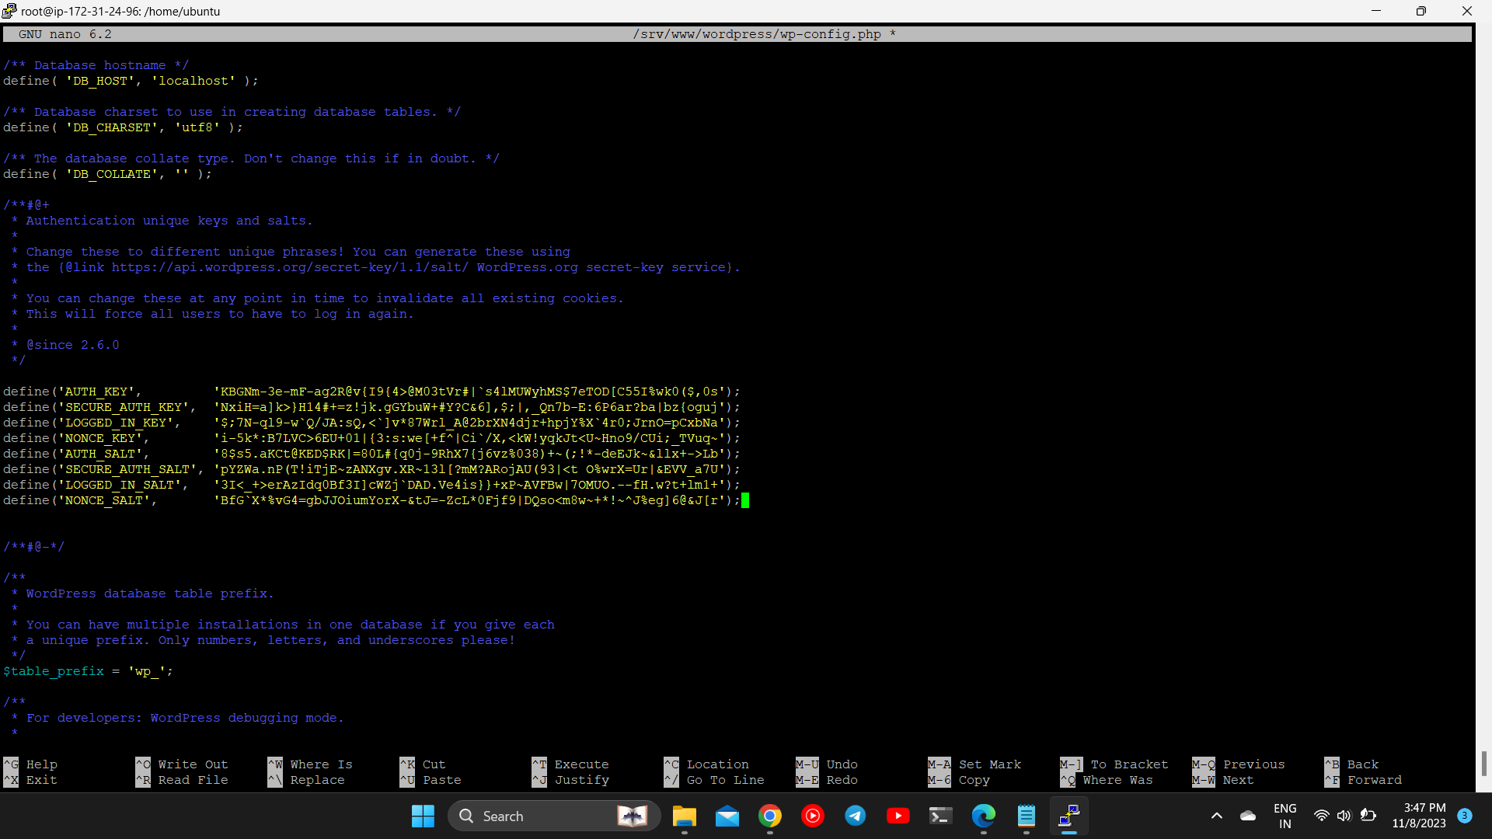

STEP 7)

Configured Wordpress.

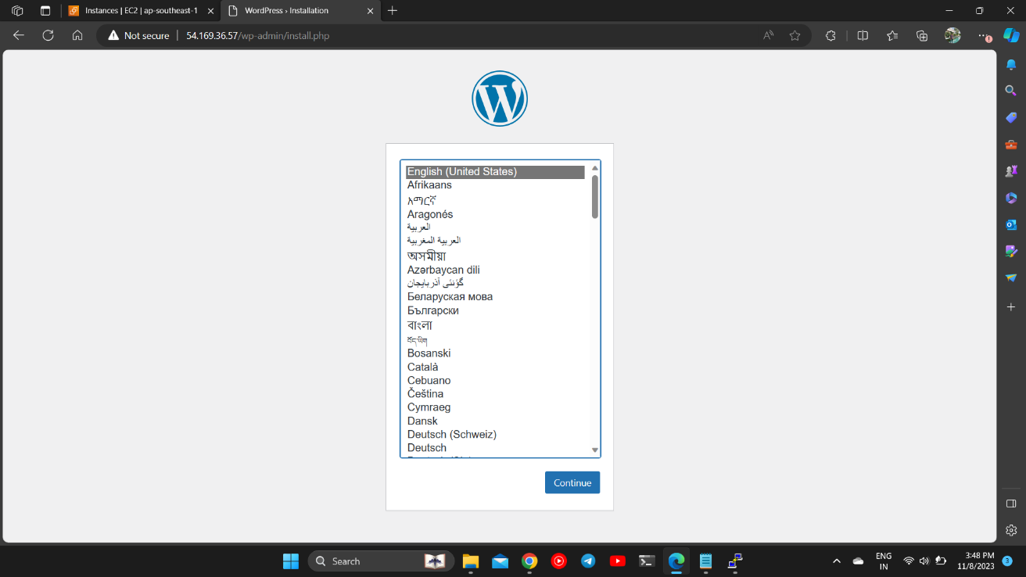

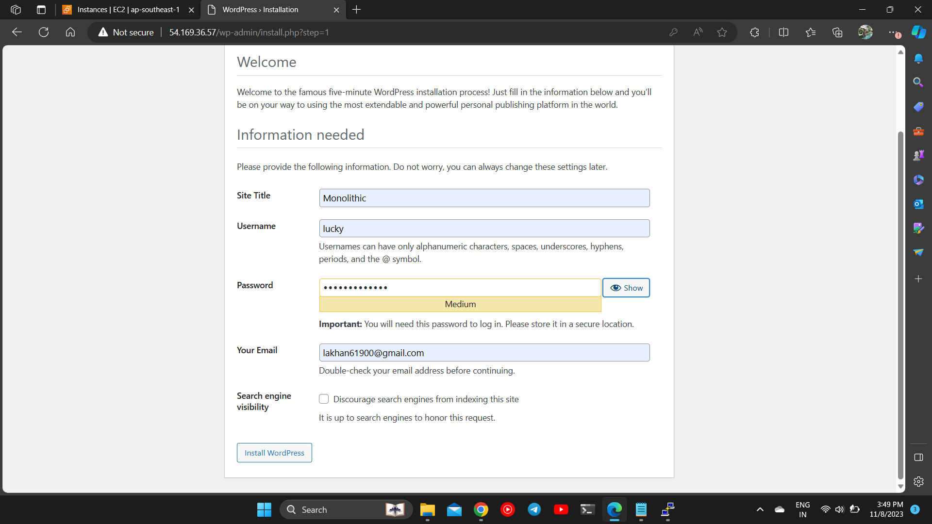

STEP 9)

Created a new post and Deployed/published it live.

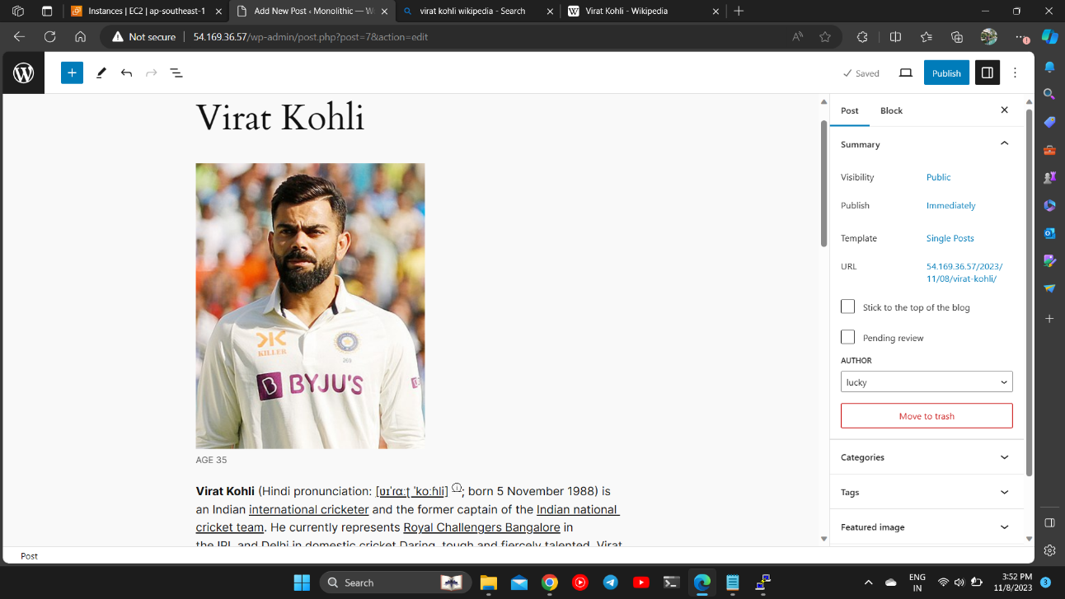

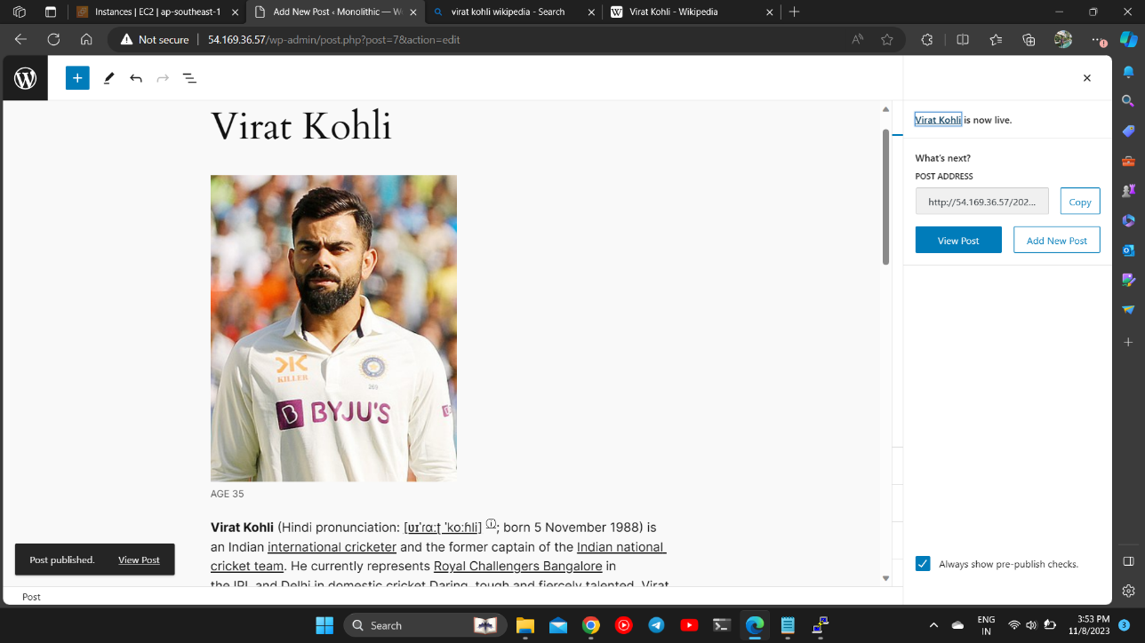

STEP 10) You can now visit our live page which gives us information about our rising star Virat Kohli.

Page Link : <http://54.169.36.57/2023/11/08/virat-kohli/>

